2026
State Championships

Texas High School Women’s Powerlifting Association
Certificate of Recognition

Name
School

Brian Thompson
Regional Director
Region VI Division 1&2
Patrick Boutwell
Business Director
Colt Henderson
Regional Director
Region VI Division III
Mike Evans
Regional Director
Region V Division I
Tomas Martinez
President
Region V Division II, III
Rodrick Portley
Vice-President
Region III Division I, II
Kenny Wilkerson
Unequipped Director

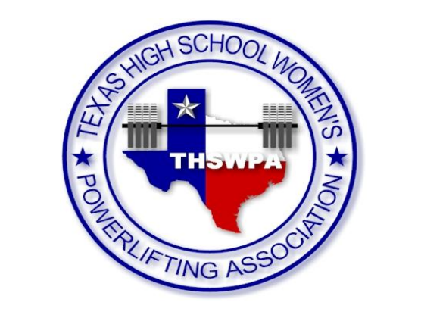
Andrew Allen
Regional Director
Region II Division I
Chris Castleman
Regional Director
Region I Division III
Fred Howard
Regional Director
Region I Division I, II
Greg Hardcastle
Regional Director
Region II Division II. III
Trey Marks
Regional Director
Region III Division III
Joe Casas
Secretary
Region IV Division I
Ron Arnesen
Regional Director
Region IV Division II, III

