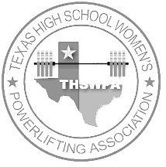
click above line and type
T.H.S.W.P.A.
Drug Testing Affidavit
It’s the purpose and Goal of the Texas High School Powerlifting Association to maintain a drug-free and wholesome environment for the young athletes of Texas, and in particular, those involved in powerlifting. Failure to present this form with the proper signatures, or failure to submit to testing as deemed necessary by the T.H.S.W.P.A. will automatically mean forfeiture of the privilege to compete in the Regional and State meets.

I, the undersigned competitor, do hereby solemnly swear that I am not presently, nor have I been, using any form of anabolic steroid, or any other such substance, in an effort to enhance my athletic abilities and performance. Furthermore agree to be tested for the use of such substances by a urine test, to be administered by the T.H.S.W.P.A. at the State Meet.

Signature of Athlete
Date
Signature of Parent or Guardian
Date
Signature of Coach
Date

