Judges Meeting- 8:15 am
Coaches Meeting- 8:30 am
Lifting Begins- 9:00 am

- This will be a THREE platform meet. WE WILL FLIGHT IT. FLIGHT INFORMATION WILL BE AVAILABLE AT EARLY WEIGH INS AND ON DAY OF THE MEET.

- T- Shirts will be on sale at the meet.

- The address of the school is:

Edcouch-Elsa High School
107 N Mile 4 W
Edcouch, TX 78538

The Hive Fine Arts

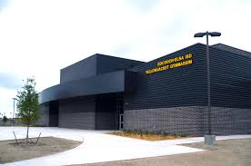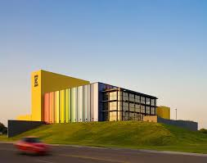

Coaches, Once you get to the High School please have your driver drop your lifters at the Hive, pictured above, and direct your drivers to park at the Fine arts building across the street. There will be more than enough parking for the buses there. If you have any other questions regarding the meet or accommodations, please do not hesitate to ask. Please share this information with your lifters and parents.
Thanks,
Christian Navarro
THSWPA Region 5, Division I Edcouch Elsa High School
Email: cnavarro@EEisd.org
Office: 956-262-4101
Cell Phone: 956-250-2076
Fax: 956-262-4103

