THSWPA REGION V
2023 REGIONAL CHAMPIONSHIPS

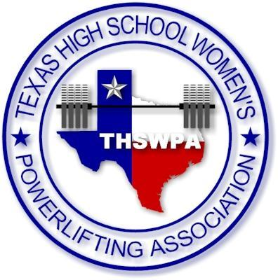
BERT OGDEN ARENA
4900 S. I-69C
Edinburg, TX 78539
ENTRY FEE $50 PER LIFTER
CHECKS PAYABLE TO
THSWPA

packets will include
1 wrist band (coach) more than number of lifters up to 3 wristband max
state qualifying lifters will receive wristband upon being weighed in
you may purchase up to 2 wrapper wristbands per team @ $10.00 each at registration

regional meet itinerary

tuesday night february 28th
early weigh ins
6A – 3:00 – 4:30
5A I – 4:00 – 5:30
5A II – 5:00 – 6:30
DHR HEALTH SPORTS & WELLNESS CENTER
315 E. PALM DR. / EDINBURG, TX 78539

wednesday march 1st
weigh ins - bert ogden arena
7:00 – 8:30 AM
6A / 5A-I / 5A-II
JUDGES MEET AT 8:15
COACHES MEET AT 8:45
BARS LOADED AT 9:30

early weigh ins
4A I – 4:00 – 5:30
4A II – 5:00 – 6:30
DHR HEALTH SPORTS & WELLNESS CENTER
315 E. PALM DR. / EDINBURG, TX 78539

thursday march 2nd
weigh ins - bert ogden arena
7:00 – 8:30 AM
4A-I / 4A-II
JUDGES MEET AT 8:15
COACHES MEET AT 8:45
BARS LOADED AT 9:30

