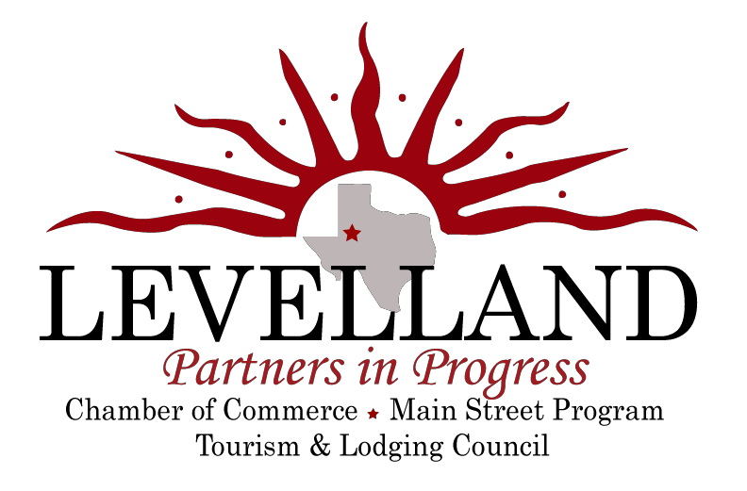

1101 Avenue H | Levelland, TX 79336 | Phone: 806-894-3157 | Fax: 806-894-4284 | www.levelland.com

L O D G I N G

Best Inn Texas (38 guest rooms) (formerly Levelland Motel)
304 College Avenue | Levelland, Texas 79336 Phone: 806-894-7335
Contact: Billy Mack Palmer or call Dillon Webb at 806-438-6043

Best Western South Plains Inn & Suites (47 guest rooms) 204 N College Avenue | Levelland, Texas 79336
Phone: 806-894-9155
Contact: Tushar Bhakta

Budget Inn of Levelland (30 guest rooms)
308 N College Avenue | Levelland, Texas 79336 Phone: 806-894-9679
Contact: Tushar Bhakta

Holiday Inn Express Hotel & Suites (62 guest rooms) 703 E. State Road 114 | Levelland, Texas 79336
Phone: 806-894-8555
Contact: Shanna McAlister

The Hope House Bed & Breakfast (2 guest rooms) 211 9th Street | Levelland, Texas 79336
Phone: 806-894-4062
Contact: John & Bette Hope

1101 Avenue H | Levelland, TX 79336 | Phone: 806-894-3157 | Fax: 806-894-4284 | www.levelland.com

