2017 MEMBERSHIP FORM
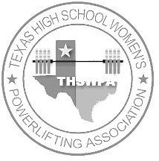 |  | t.h.s.w.p.a.  THSWPA 2017-2018 STATE MEET WILL BE IN WACO
Texas high school women’s powerlifting association
governing the strongest texas high school women’s sport
over 500 member schools from 6 regions
18 scholarships given annually
apx 600 lifters at the state meet held in waco 2017 and 2018
t.h.s.w.p.a. membership registration form
 | all participating schools must pay a membership fee of $75.00.
 | payment must be postmarked by February 1, 2017.
 | there is also a 35.00 per lifter fee that is to be paid at both the regional and state meets.
 | if school membership fee is received after February 1, 2017, a late fee of $200.00 will be added.
please complete the following information and include with annual dues and mail to:
THSWPA
PO Box 3021
Brownsville, Texas 78523
make $75.00 check payable to the texas high school women’s powerlifting association (THSWPA)
school name
complete school address
coach name
coach email
coach phone #
please circle the appropriate class, region and division
uil class: |  | 1a |  |  | 2a |  | 3a |  | 4a |  |  | 5a |  | 6A | t.h.s.w.p.a. region |  |  | i | ii |  | iii |  | iv |  |  | v |  | vi
powerlifting division |  |  |  |  |  |  |  | 1 |  |  | 2 |  | 3

