Hotel List for Regionals
The following hotels provided block rates for the Region 1 meet
The Blocks are set up between the February 29th and March 1st
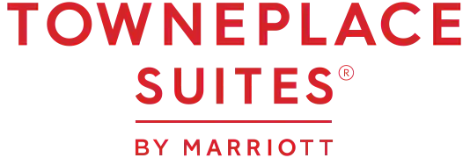
$99 Plus tax, when booking ask for the group rate(Block) under Big Spring Powerlifting or Sawyer Roberts

$109 Plus tax, when booking ask for the group rate(Block) under Big Spring Powerlifting or Sawyer Roberts

